1. 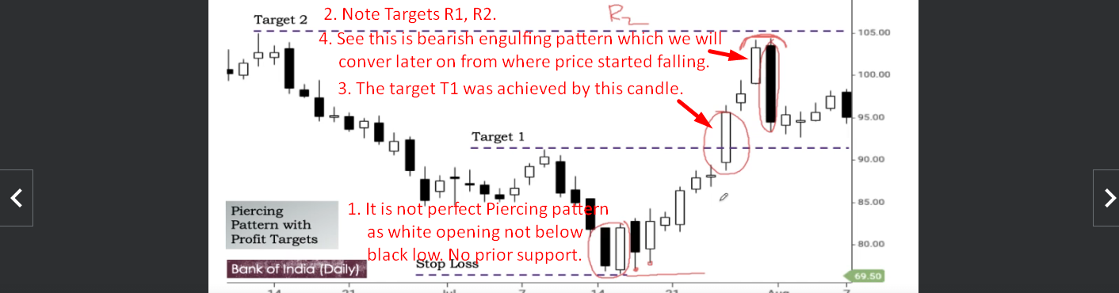  
   Above note that the support created by piercing pattern (the low of the pattern) is not broken. That is the power of piercing pattern’s support.
2. A diagram of a candle stick graph

   Description automatically generated